Basic Shell Scripts

Script 1: Output to screen
#!/bin/bash
# Simple output script
echo "Hello World"
Commands Executed:
vi HellWorld.bash
cat HelloWorld.bash
chmod 755 HellWorld.bash
./HellWorld.bash
Screenshot:
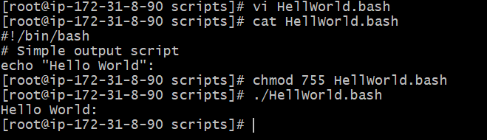

Script 2 :Defining Tasks
#!/bin/bash
# Define small tasks
Whoami
echo
pwd
echo
hostname
echo
ls -ltr
echo
Commands Executed:
vi Task.bash
cat Task.bash
chmod 755 Task.bash
./Task.bash
Screenshot:
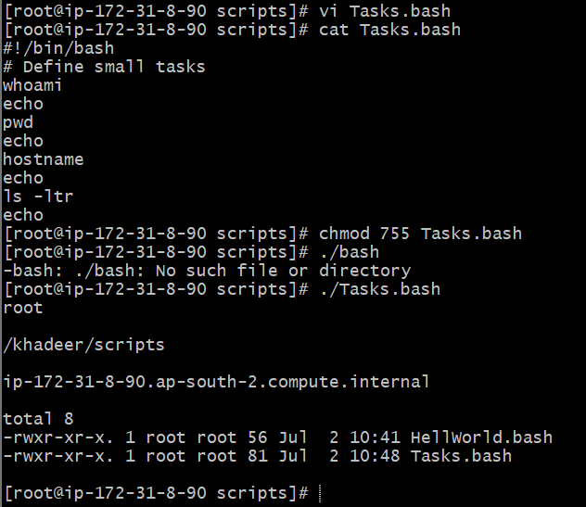

Script 3 :Defining variables
#!/bin/bash
# Example of defining variables
a=Imran
b=Afzal
c=’Linux class’
echo "My first name is $a"
echo "My surname is $b"
echo ‘My surname is $c’
Commands Executed:
vi Varaiable.bash
cat Varaiable.bash
chmod 755 Varaiable.bash
./Varaiable.bash
Screenshot:
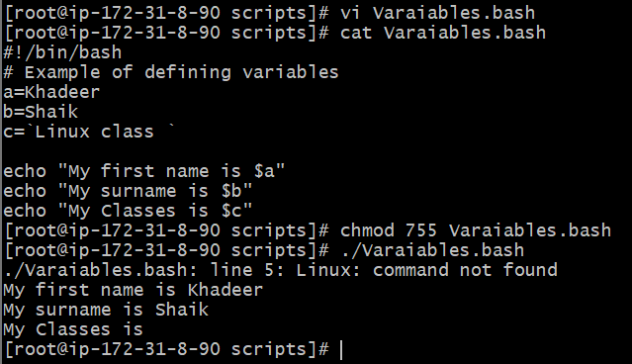

Scripts 4: Read Input
#!/bin/bash
# Read user input
echo "What is your first name?"
read a
echo
echo "What is your last name?"
read b
echo
echo Hello $a $b
Commands Executed:
vi userInput.bash
cat userInput.bash
chmod 755 userInput.bash
./userInput.bash
Screenshot:
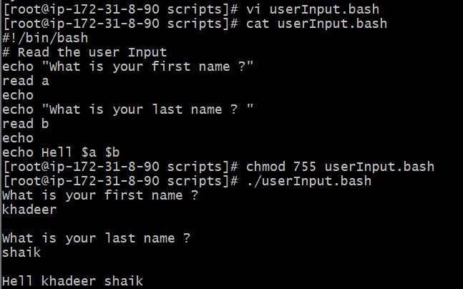

Script 5 : Scripts to run commands within
#!/bin/bash
# Script to run commands within
clear
echo "Hello `whoami`"
echo
echo "Today is `date`"
echo
echo "Number of user login: `who | wc -l `"
echo
Commands Executed:
vi userdeatils.bash
cat userdeatils.bash
chmod 755 userdeatils.bash
./userdeatils.bash
Screenshot:
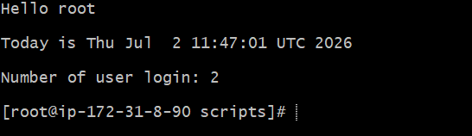

Script 6 : Read input and perform a task
#!/bin/bash
echo "Enter the file name to be renamed"
read oldfilename
echo "Enter the new file name"
read newfilename
mv -- "$oldfilename" "$newfilename"
echo "The file has been renamed as $newfilename"
Commands Executed:
vi Rename.bash
cat Rename.bash
chmod 755 Rename.bash
./Rename.bash
Screenshot:
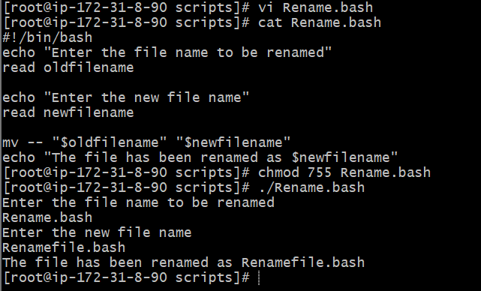
Script7 : To perform a task
#!/bin/bash
Free -m
Ps -ef
df -h
du -sk
Commands Executed:
vi testing.bash
cat testing.bash
chmod 755 testing.bash
./testing.bash
Screenshot:
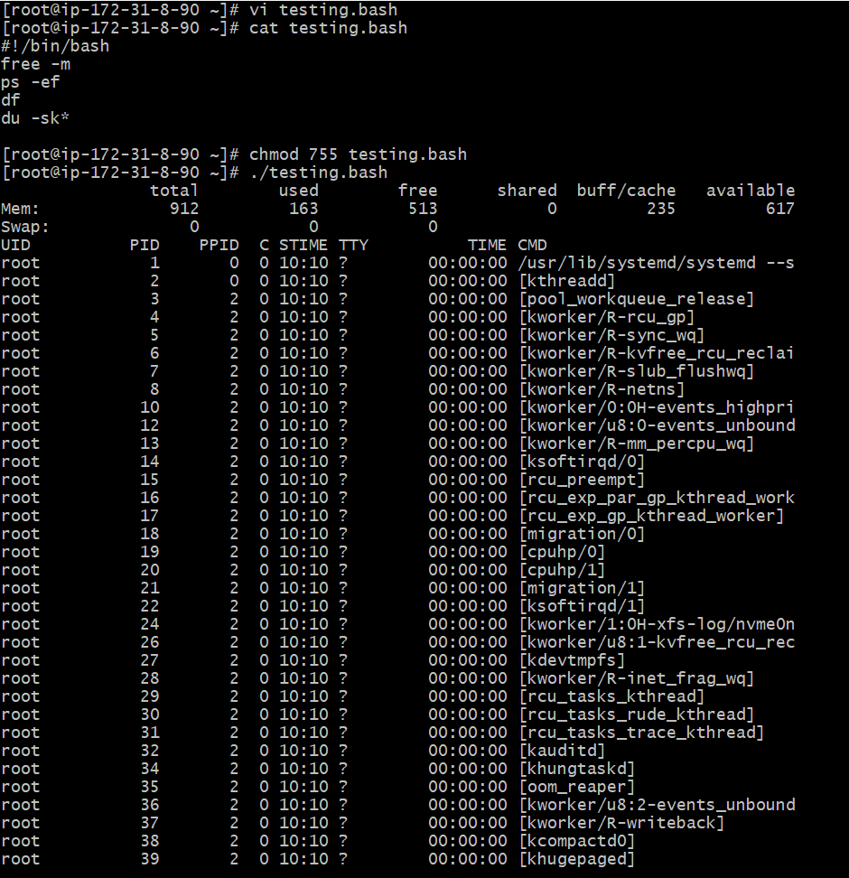
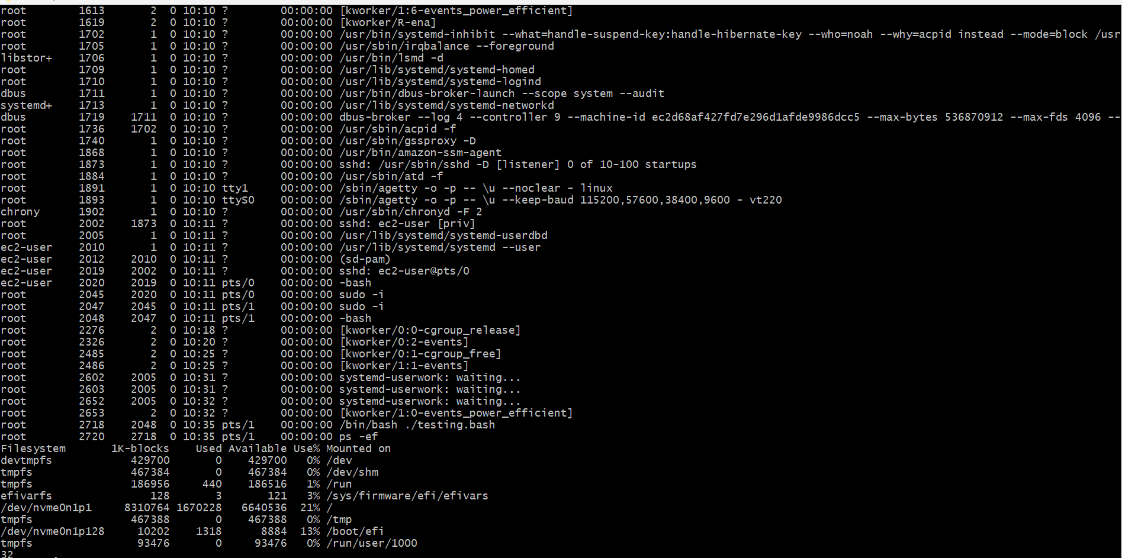
Script 8 : To show Sequence execution of Commands
#!/bin/bash
whoami
date
cal 2026
Commands Executed:
vi commands.bash
cat commands.bash
chmod 755 commands.bash
./commands.bash
Screenshot:
